**ViewPoint Page Design**

**Elements:**

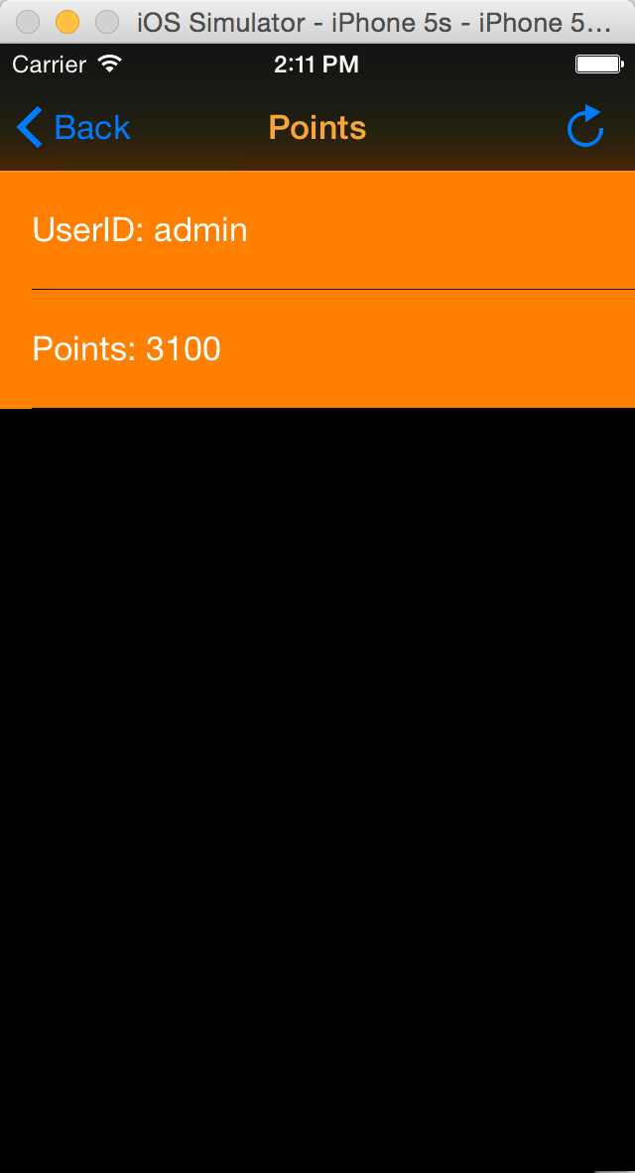

Title: “Points”, orange

Navigation left button: “Back”, blue; back to last page(menu)

Right bar button:

Update the users’ point

View Backgroud: black

Cell Background: brown

Cell content:

white text

“UserID:…” and “Points:…”